Mac Terminal - WIN Cmd Box
Written by Roger Pfister http://RogerPf.com/aaBridge
In a number of places when wanting to work with text files it is useful to work with what is sometimes called the command line interface.
Basically you type in a line (or command) and the computer does "stuff".
The two sections that follow cover both Windows and MAC. Both sections cover exactly the same ground. So you only need to read the section that matches your computer.
Linux users are expected to know this sort of thing already. However, they will find their world is almost exactly the same as the MAC Terminal.

The example files used in this document have to come from somewhere. Rather than create files explicitly for this text the example files have been taken from the Deal and Merge package.
For those who are interested in the actual files they can be found in the aaBridge doc collection Deal and Merge package which is in the zip file
aadm__package__vN.NN.zip (where N.NN is a version number)
the example files will then be found in the dealer_scripts folder.

If you want to follow along with any examples you will need to have already run the have unzipped the aadm package and successfully run SETUP as described in the file
aadm__READ-ME.doc
and be working in the folder
dealer_scripts

NOTE - You do not need to do the above. It is fine to just follow along with your own directory and use the files and commands you have in it.

1. Mac Terminal
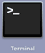
Using Launchpad > other > Terminal will start a terminal window.
However that is not a sensible way to do it. This is because you almost always want your terminal window to start in a particular folder.
Instead, first you need to turn on the ability to have a Terminal Window wherever you want (in MAC speak this is called a "service").

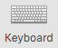
Under System preferences Select Keyboard
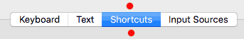
then click the Shortcuts option (red dots).

Still in that same dialogue box in the left-hand click the Services cog (red dot).
In the right hand side scroll down until you can see the two New Terminal ... entries.
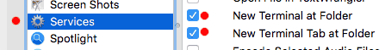
Check them both as shown (red dots).

NOW, we can now relatively easily, open a terminal window with the folder we want.
Select the folder, here dealer_scripts (bring up the menu with the right button or a two fingered tap) and select Services.
Click on either of the two New Terminal ... options (red dots).
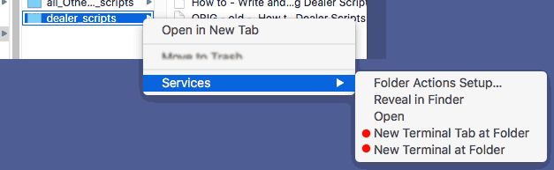

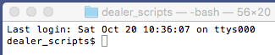
And a Terminal window will open
already set to that folder (here dealer_scripts).
MAC History
When you type any command such as ls (list the files in this folder) it is remembered in the "recently" entered command History.
Type ls into the terminal window (and press the "Enter" key) and a list of files in that folder will be displayed.
When you click the Up Arrow on you keyboard the previous command will be shown to you (in this case ls) and you can again press Enter to re-run it.
The history is also remembered between sessions so it you typed a long command in a previous session you do not have to type it again.
There are lots of additional features to 'History' to find them
google bash history
(for this feature is the same on both MAC and Linux)

MAC Filename completion (TAB key)
If you have a command in the folder that the terminal window is open to (in this case there are two such files dealer and aadm.command) THEN you can get the system to do Filename compeltion for you.
at the ...$ prompt type ./d and then press the TAB key
the ...$ ./d will then expand to
...$ ./dealer
now type just the letter t at the end of that line and again press the TAB key
...$ ./dealer t will then expand to
...$ ./dealer test_and_play.txt
and you can press Enter and run the line without having to type in long filenames.
Of course that long command is now be in the HISTORY.
Note - if you have other files that start with the letter t then a second press to the TAB key will show you a list of the matching files and you can type a bit more and again press TAB.
2. WIN Cmd Box
It is in theory possible to set up an 'Open command window here' option in the folder menu in Windows Explorer. You are free to google and try to find such options. Sadly Microsoft has chosen to make it incredibly painful to set this up for Windows 10.
Here the term Cmd Box is used as it is shorter than Command Window and is less likely to generate any confusion with the MAC use of the word 'command'.
Luckily because on Windows we need to install the notepad++ we can use this to do what we want.
Windows users should have already installed notepad++ if you haven't. see the document:
Notepad++ How to setup for Windows.doc
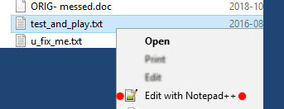
Open Notepad++ in the folder where you want the Cmd Box.
This is of course normally done by using the right button mouse menu when pointing at ANY FILE in the folder in File Explorer.
Here the file is called test_and_play.txt but any file will do
Click the Edit with Notepad++ option (red dots).
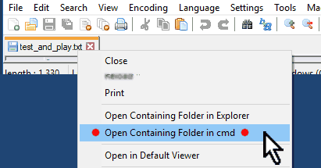
Now in notepad++ do a right click on the tab of that file to bring up the menu and then select
Open Containing Folder in cmd
as shown in the image on the right (red dots) .

A Cmd Box will open for that folder see below.

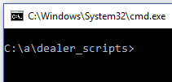

WIN History
When you type any cmd such as dir (directory of the list of files in this folder) it is remembered in the "recently" entered command History.
Type dir into the cmd box (and press the "Enter" key) and the list of files in that folder will be displayed.
When you click the Up Arrow on you keyboard the previous command will be shown to you (in this case ls) and you can press Enter to re-run it.
The history is also remembered between sessions so it you type a long command before you do not have to type it again.
There are lots of additional features to 'History' to find them
google bash history
(for this feature is the same on both MAC and Linux)

WIN Filename completion (TAB key)
If you have a command in the folder that the Terminal window is open to (in this case there are two such files dealer and aadm.cmd) THEN you can get the system to do FILE NAME compeltion for you.
at the ...> prompt type d and then press the TAB key (you many need .\d )
the ...> d will then expand to
...> dealer
now type just the letter t at the end of that line and again press the TAB key
...> dealer t will then expand to
...> dealer test_and_play.txt
and you can press Enter and run the line without having to type in long file names.
And of course that long command is now in the HISTORY.
Note - if you other files that start with the letter t then a second press to the TAB key will show you the name of the next matching file, you can press tab again see the next TAB.
<end of document>

